**Demo 2a - Removing a NuGet Package**

**Using the Add Library Package Reference Dialog Box**

This topic describes how to remove a NuGet package using the **Add Library Package Reference** dialog box. As an alternative, you can remove packages using PowerShell commands. For more information, see [Removing a NuGet Package Using the Package Manager Console](http://nuget.codeplex.com/wikipage?title=Removing%20a%20Package%20Using%20the%20Package%20Manager%20Console).

In **Solution Explorer**, right-click the project, click **Add**, and then click **Add Library Package Reference**.

[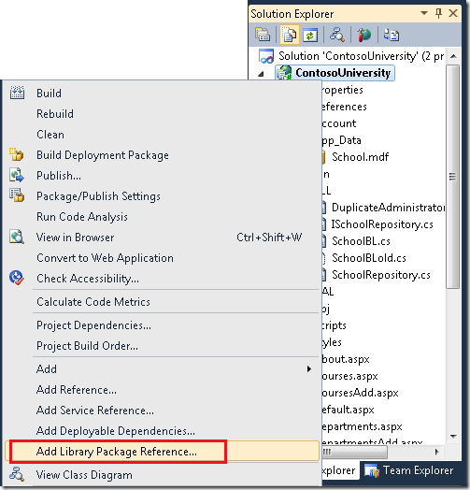](http://download.codeplex.com/Project/Download/FileDownload.aspx?ProjectName=nuget&DownloadId=189348)

The **Add Library Package Reference** dialog box opens with the **Installed Packages** tab selected and displays installed packages.

[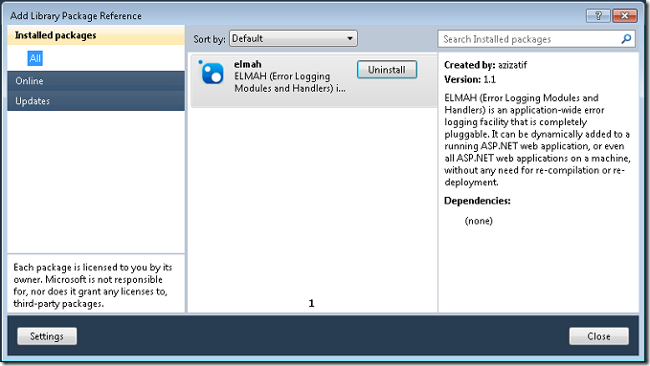](http://download.codeplex.com/Project/Download/FileDownload.aspx?ProjectName=nuget&DownloadId=187027)

Select the package you want to uninstall and then click **Uninstall** to remove the package.

The following package elements are removed:

* References in the project. In **Solution Explorer**, you no longer see the library in the *References* folder or the *bin* folder. (You might have to build the project to see it removed from the *bin* folder.)
* Files in the solution folder. The folder for the package you removed is deleted from the *packages* folder. If it is the only package you had installed, the *packages* folder is also deleted.)
* Any changes that were made to your *app.config* or *web.config* file are undone.

If other packages were installed because they were dependencies of the package that you removed, you might want to remove them also.

**Using the Package Manager Console**

This topic describes how to remove a NuGet package using PowerShell commands.

From the **Tools** menu, select **Library Package Manager** and then click **Package Manager Console**.

If you do not already know the name of the package you want to remove, enter get-package at the prompt to see a list of all of the packages that are currently installed.

[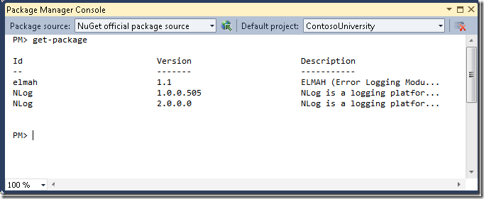](http://www.codeplex.com/Project/Download/FileDownload.aspx?ProjectName=nuget&DownloadId=168858)  
To remove a package, use the uninstall-package command with the name of the package. For example, use the install-package elmah command as shown in the following example:

[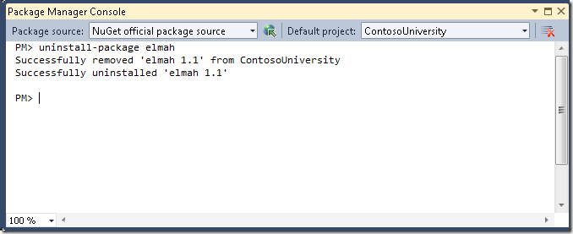](http://download.codeplex.com/Project/Download/FileDownload.aspx?ProjectName=nuget&DownloadId=189379)

For more options that you can specify with the uninstall-package command, enter get-help uninstall-package or see [Package Manager Console Commands](http://nuget.codeplex.com/documentation?title=Package%20Manager%20Console%20Command%20Reference).

All traces of the package are removed:

* References in the project. In **Solution Explorer**, you no longer see the library in the *References* folder or the *bin* folder. (You might have to build the project to see it removed from the *bin* folder.)
* Files in the solution folder. The folder for the package you removed is deleted from the *packages* folder. If it is the only package you had installed, the *packages* folder is also deleted.
* Any changes that were made to your *app.config* or *web.config* file are undone.

If other packages were installed because they were dependencies of the package that you removed, and if no other packages remain that are dependent on the dependency packages, the dependency packages are also removed.